TOPIC:

***ONLINE SHOPPING WEBSITE***

ABSTRACT

I’ve made an online shopping website. It is a static website in which we can search product and also add the product in cart.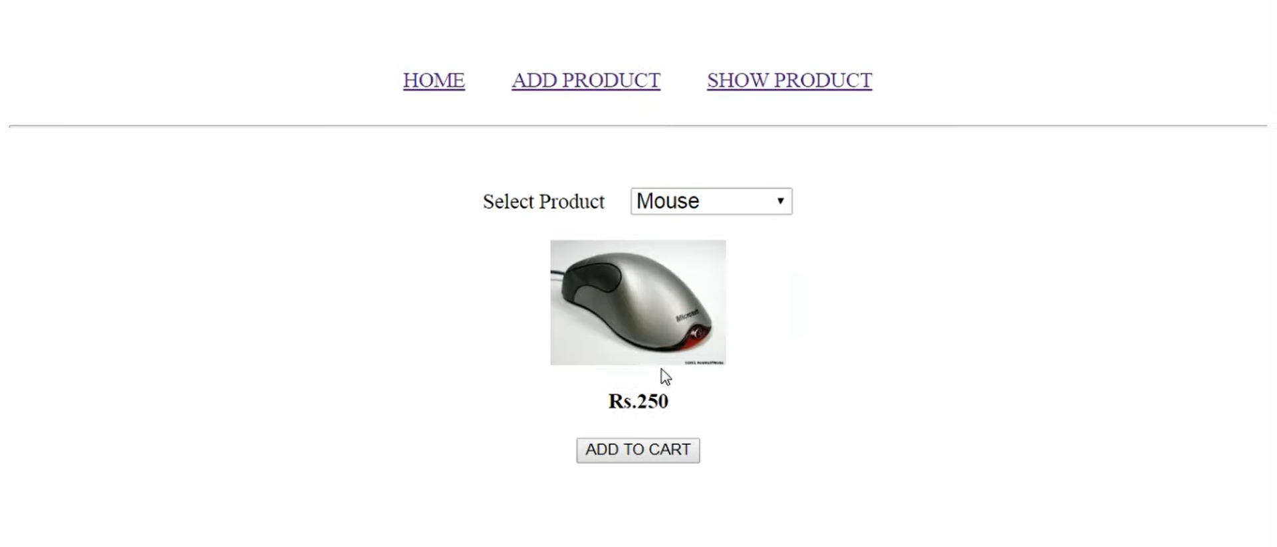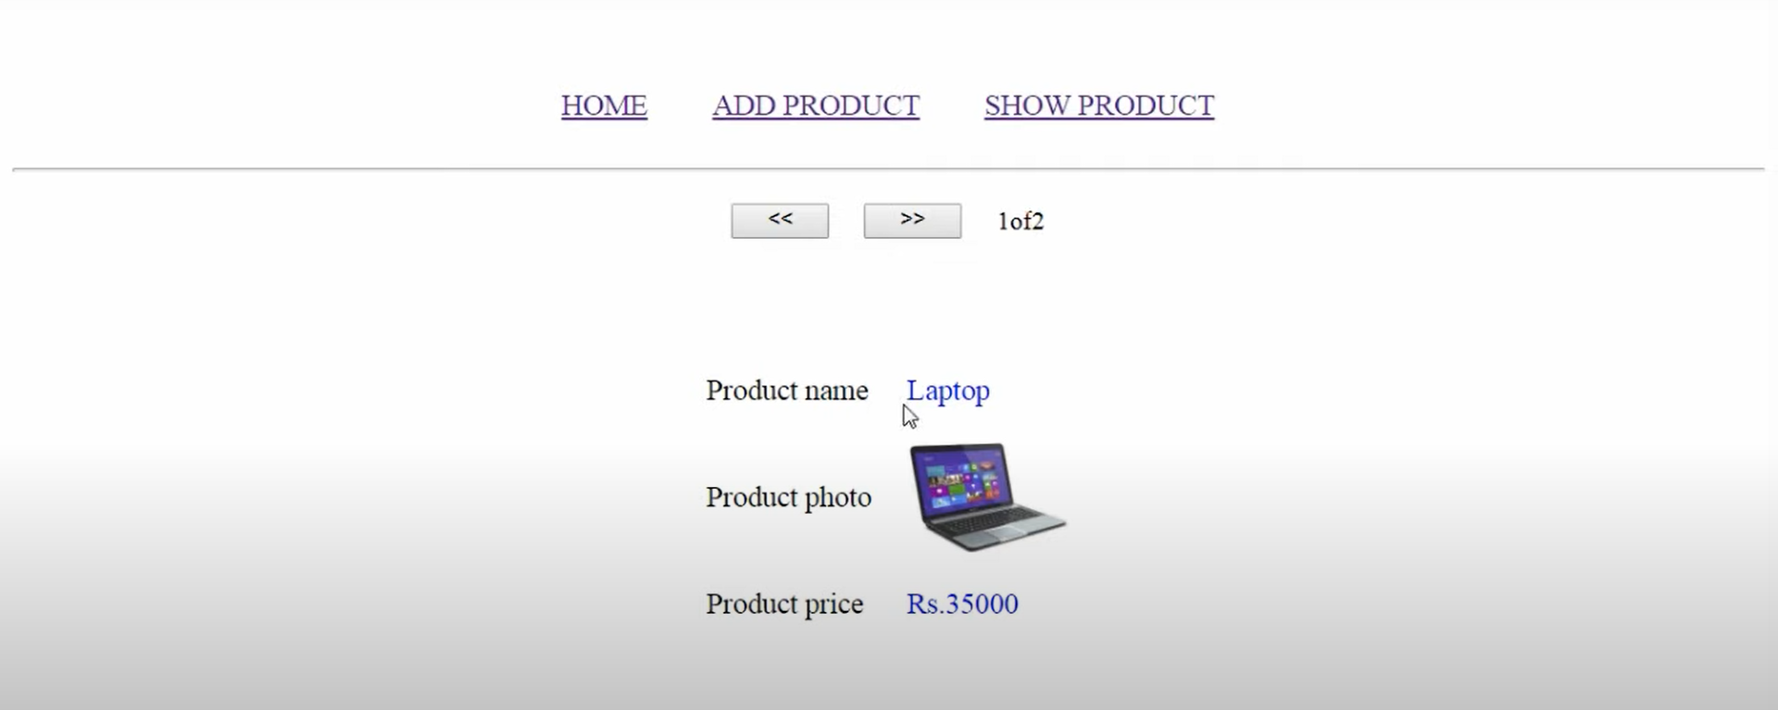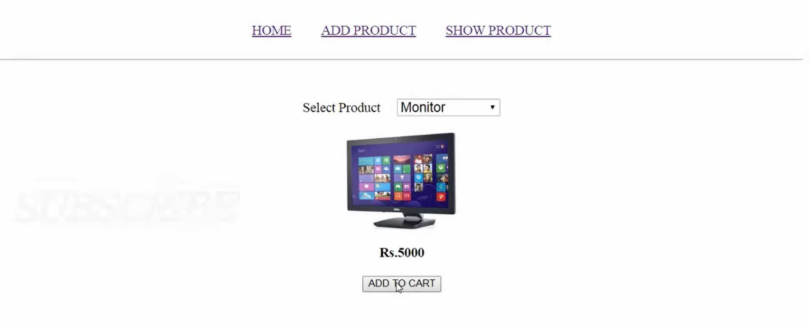

MODULES:

* ADDPRODUCT:

|  |
| --- |
| using System;  using System.Collections.Generic;  using System.Linq;  using System.Web;  using System.Web.UI;  using System.Web.UI.WebControls;  public partial class AddProduct : System.Web.UI.Page  {  protected void Page_Load(object sender, EventArgs e)  {  }  protected void DropDownList1_SelectedIndexChanged(object sender, EventArgs e)  {  string[] price = { "", "35000", "23000", "5000", "700", "250" };  Image1.ImageUrl = "pics/" + DropDownList1.Text + ".jpg";  int i = DropDownList1.SelectedIndex;  Label1.Text = "Rs." + price[i];  Button1.Visible = true;  }  protected void Button1_Click(object sender, EventArgs e)  {  if (ItemAdded(DropDownList1.Text))  {  Response.Write("<script>alert('selected item is already added in cart')</script>");  return;  }  Session["ctr"] = (int)Session["ctr"] + 1;  Product proj = new Product(DropDownList1.Text, Image1.ImageUrl, Label1.Text);  Session["p" + Session["ctr"]] = proj;  Server.Transfer("Add.aspx");  }  bool ItemAdded(string name)  {  bool found = false;  for (int c = 1; c <= (int)Session["ctr"]; c++)  {  Product p = (Product)Session["p" + c];  if (name == p.name)  {  found = true;  break;  }  }  return found;  }    } |

* ADD

|  |
| --- |
| using System;  using System.Collections.Generic;  using System.Linq;  using System.Web;  using System.Web.UI;  using System.Web.UI.WebControls;  public partial class Add : System.Web.UI.Page  {  protected void Page_Load(object sender, EventArgs e)  {  }  } |

* DEFAULT:

|  |
| --- |
| using System;  using System.Collections.Generic;  using System.Linq;  using System.Web;  using System.Web.UI;  using System.Web.UI.WebControls;  public partial class _Default : System.Web.UI.Page  {  protected void Page_Load(object sender, EventArgs e)  {  }  } |

* SHOWPRODUCT:

|  |
| --- |
| using System;  using System.Collections.Generic;  using System.Linq;  using System.Web;  using System.Web.UI;  using System.Web.UI.WebControls;  public partial class ShowProduct : System.Web.UI.Page  {  static int c;  protected void Page_Load(object sender, EventArgs e)  {  if (!Page.IsPostBack)  {  if (Session["p1"] == null)  {  pd.Visible = false;  Label3.Visible = true;  return;  }  Button1.Visible = true;  Button2.Visible = true;  c = 1;  showItem(c);  }  }  protected void Button1_Click(object sender, EventArgs e)  {  if (c == 1)  {  Response.Write("<script>alert('this is first product')</script>");  return;  }  showItem(--c);  }  protected void Button2_Click(object sender, EventArgs e)  {  if (c == (int)Session["ctr"])  {  Response.Write("<script>alert('this is LAST product')</script>");  return;  }  showItem(++c);  }  void showItem(int pn)  {  Label4.Text = pn + "of" + Session["ctr"];  Product pd = (Product)Session["p" + pn];  Label2.Text = pd.name;  Image1.ImageUrl = pd.image;  Label1.Text = pd.price;  }  } |

* PRODUCT:

|  |
| --- |
| using System;  using System.Collections.Generic;  using System.Linq;  using System.Web;  /// <summary>  /// Summary description for Product  /// </summary>  public class Product  {  public string name, image, price;  public Product(string na,string img,string pr)  {  name = na;  image = img;  price = pr;  }  } |